THE PROGRAM: The Field Stewards program rewards farmers for protecting water quality, helps food companies address sustainability challenges in their supply chains and provides consumers the opportunity to support cleaner water with their purchases. The program rewards farmers for reaching and maintaining a high level of water quality protection on their farms. The producer works with a Field Stewards Certified Field Representative to review farm practices and meet program requirements. Only those farmers who meet and exceed the standards that protect the land and water are eligible for participation in the Field Stewards program. Maintaining the water quality friendly practices necessary to meet the certification threshold on a farm requires dedication to a very high level of environmental performance.
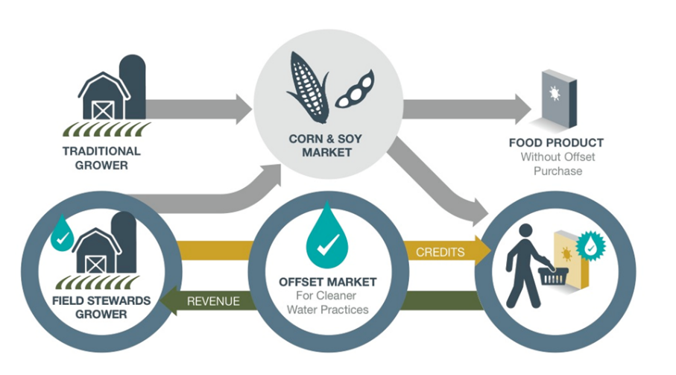
If a farmer does not meet the initial requirements for participation, the farmer may be asked to make some changes to complete the application or to correct the deficiencies found during the farm inspection. Also, the farmer may choose to file an appeal.
Payments for these efforts are provided through an “offset market” in the form purchased certificates for certified Field Stewards acres. Food companies that want to support clean water purchase certificates to offset their supply chain corn and soybean inputs. The farmer then receives payments for those purchased certificates. The Field Stewards Administrator locates purchasers for certificates and makes all final determinations about the program.

YOUR PRIVACY: Field Stewards takes your privacy seriously. Each producer must give permission for the Field Representative to share personal and operation information with the Field Stewards Aggregator’s Office and a Third Party Verifier. Each producer must also give permission to share some information with the Program Administration as needed to administer the program, such as making determinations about which farmers meet the very high standards required for participation in the Field Stewards program. Other parties will only have access to information that does not have individual producer information, such as number of applicants and number of participating producers.

THE PROCESS:

- OR -
AND
AND
AND

