THE PROGRAM: The Field Stewards program rewards conscientious farmers for protecting water quality, helps food companies address sustainability challenges in their supply chains and provides consumers the opportunity to support cleaner water with their purchases. The program rewards farmers for reaching and maintaining a high level of water quality protection on their farms. The producer works with a Field Stewards Certified Field Representative to review farm practices and meet program requirements. Only those farmers who meet and exceed the standards that protect the land and water are eligible for participation in the Field Stewards program. Maintaining the water quality friendly practices necessary to meet the certification threshold on a farm requires dedication to a high level of environmental performance.
Thank you for making the efforts needed to meet these requirements.
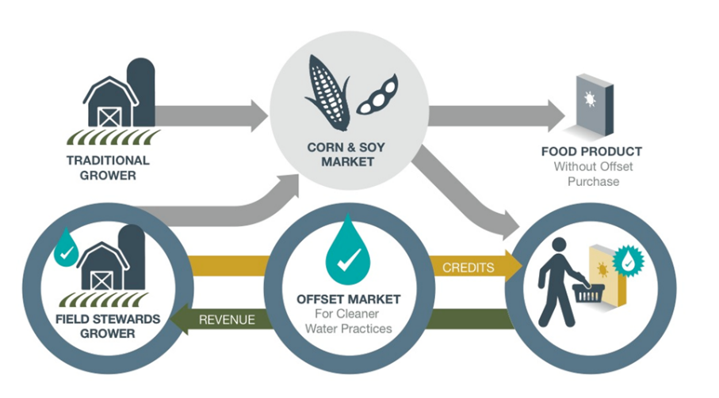
Payments for these efforts are provided through an “offset market” in the form purchased certificates for your certified Field Stewards acres. Food companies that want to support clean water purchase certificates to offset their supply chain corn and soybean inputs. The farmer then receives payments for those purchased certificates. The Field Stewards Administrator locates purchasers for certificates and makes all final determinations about the program.

YOUR PRIVACY: Field Stewards takes your privacy seriously. Each producer must give permission for the Field Representative to share personal and operation information with the Field Stewards Aggregator’s Office and a Third Party Verifier. Each producer must also give permission to share some information with the Program Administration as needed to administer the program, such as matching producers with available certificate purchasers. Other parties will only have access to information that does not have individual producer information, such as number of participating producers and total program acres.

THE PROCESS:

AND
AND
AND
AND
AND
AND

